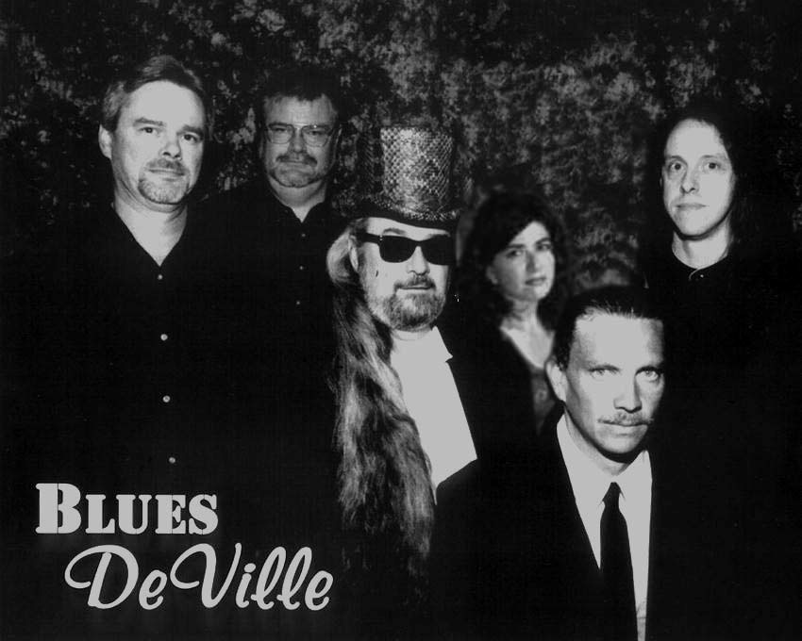

Blues DeVille is an authentic blues band specializing in the Chicago sound with a decidedly danceable groove. Based in central Arkansas, they bring a wide range of talent to bear including powerful vocals, harmonica, piano, Hammond organ, saxophone, guitar, slide guitar, and one of the tightest drum/bass rhythm sections to be found anywhere. Their repertoire includes songs by Muddy Waters, Howlin' Wolf, B.B. King, Otis Rush, Buddy Guy, Freddie King, Lightnin' Hopkins, and Albert King as well as original compositions. Band members include:

Angela Wood – drums
The newest member of Blues Deville, Angela began playing drums and percussion in the 80's. She has performed professionally in and around Arkansas since 1994 with local bands Don't Pet The Kat and Red Head Molly. Her musical influences include Led Zeppelin; Rare Earth; Earth, Wind and Fire; and local drum guru Charlie Macom. Angela is a no-nonsense, hard-hitting drummer providing a solid backbone for this serious, "Off The Hook" blues band.
Stevie Sowell – vocals, piano, Hammond organ, saxophone
Lil’ Stevie Sowell began playing music in 1963. He studied saxophone in high school band and learned to play keyboards by watching his mother, who was the piano player at their church. Stevie played with several gospel groups over the years, began playing secular music in 1971, and was a founding member of Blues DeVille. Stevie contributes rollicking roadhouse piano, swirling Hammond organ, and soulful sax solos, as well as vocals and occasional sidesplitting humor. There's never a dull moment when Lil' Stevie's in the house.

Lee Costley – vocals, guitar
Lee was born on a cotton farm in the Arkansas delta and by age 3 was singing gospel harmonies with his mother and sister. He began playing guitar when he was 8 years old. At age 15 he became the lead guitar player for Fred Crook's Freaky Blues Band. A founding member of Blues DeVille, powerful vocals and deeply rooted blues guitar are his specialties.

Keith Nash – guitar
Keith began playing guitar in 1971 and has played professionally in the central Arkansas area since moving here in 1975. Besides playing numerous shows and club dates, he has opened concert and festival appearances for several star acts over the years. His tasteful guitar and blistering slide work complement Blues Deville’s powerhouse sound.

Kent E. Moler – harmonica
Kent is a high-energy performer whose credits include a three-year stint with The Blues Patrol, a popular local band that released an album ("The Blues Patrol recorded live at the White Water Tavern") and performed at Antone's for the South by Southwest music showcase in 1991. He has also appeared with Shannon Boshears and other artists. Kent joined Blues DeVille in 1995, bringing his barrelhouse Chicago blues harmonica style into full focus, igniting the band with incendiary solos and spirited performances.

Jimmy Lynn - bass
Jimmy got his start in 1980 and has played with Liquid Groove Mojo, Brenda Smith, Mark Sallings, and The Famous Unknowns. Jimmy lays down the stalwart foundation of Blues Deville’s driving sound, a foundation that makes you want to dance and have a fun.

Blues DeVille is available to play festivals, concerts, clubs, and parties.
Visit our website at www.bluesdeville.net
Or contact:

Keith Nash
(501)758-3104
booking@bluesdeville.net

